STUDENT/PARENT HANDBOOK
2022-2023

1809 Clarkson Road
Chesterfield, MO 63017
Phone: 636-778-1896
Fax: 636-778-1899
Email: hs@missouritorah.org
www.missouritorah.org

TABLE OF CONTENTS
APPLYING FOR ADMISSION TO MTI 4
TADS 4
IMMUNIZATIONS AND HEALTH EXAMINATIONS 4
BOOKS/SEFORIM & SCHOOL SUPPLIES 4
PACKING LIST 5
OBSERVANCE OF HALACHA 6
MUSIC & DEVICES FOR PLAYING MUSIC 6
COMPUTERS AND OTHER ELECTRONIC DEVICES 6
SUBSTANCE ABUSE 6
SOCIALIZING 7
SUMMER ACTIVITIES 7
MEDIA 7
INTERNET/SMARTPHONES AT HOME 7
CELL PHONE POLICY 8
PRESCRIPTION MEDICATION POLICY 9
DRESS CODE 10
SCHOOL ATTENDANCE POLICIES 11
DRIVING TO Yeshiva 11
STUDENT PASSENGER POLICY 11
MISSING YESHIVA 11
YESHIVA CALENDAR & TRAVEL 12
SNOW DAYS 12
CLOSED CAMPUS POLICY 12
DAVENING 12
NIGHT SEDER 13
STUDENT ID CARDS 13
ACADEMIC POLICIES 14
ONLINE GRADEBOOK – JUPITER 15
GRADUATION REQUIREMENTS 14
PERMANENT RECORDS/TRANSCRIPTS 15
DORMITORY POLICIES 16
POLICIES RELATING TO SAFETY AND DAMAGES 18
FOOD 19
LAUNDRY & DRY-CLEANING 20
LOCKERS 20
LOST AND FOUND 20
ILLNESS 20
SPECIAL EVENTS AND FIELD TRIPS 20
OUT SHABBOS 21

OUR APPROACH

Missouri Torah Institute is a yeshiva where talmidim work together with rebbeim and teachers to experience academic, emotional, and spiritual growth appropriate for their individual capacity, developing a love for Hashem, for themselves, and for learning. MTI is a rigorous Torah and general studies education which engages the whole student; it engenders steady, growing maturity that comes through learning and Jewish discovery; it encourages a sophisticated understanding of each Jew's relationship with Hashem, enhanced by understanding of self and substantial scholarship. This holistic - mind, heart, and soul - approach to chinuch guides everything at MTI.

Missouri Torah Institute is staffed by rebbeim and teachers who are committed to creating a structured environment that supports developmentally appropriate growth. Rebbeim and teachers at MTI work to understand how individual talmidim learn and what helps them grow. They remain closely engaged with talmidim's daily life, yet maintain a healthy distance, allowing talmidim to make the decisions that will help them to achieve steady growth in their high school years. MTI staff are aware of how the social, emotional, and spiritual aspects of talmidim's daily life are integral to academic success. The mutual respect and trust and the shared goals MTI teachers and rebbeim have with their talmidim allows them to enjoy a positive, productive relationship and achieve amazing success together.

Missouri Torah Institute talmidim are self-respecting young men who seek to learn, come closer to Hashem, and enjoy the company of friends. Their genuine desire to be a member of the MTI school community helps them maintain the clearly communicated and mutually agreed-upon expectations that ensure a productive and safe school environment. MTI talmidim know that accountability for what they do and the choices they make is theirs alone, allowing them to celebrate the sweet taste of their successes and learn from their missteps. MTI talmidim know that they can be successful in the school environment when they consider their hearts and souls as well as their minds. They know that finding the keys to success in school will help them unlock the doors to fulfillment in their avodas Hashem, family, and career.

Missouri Torah Institute parents love and respect their sons and send them to yeshiva to give them the invaluable opportunity to learn, mature, and achieve success in their teenage years. MTI parents have the patient understanding that meaningful, lasting growth takes time, and that with abundant love, engagement, and support they can help their sons become truly great men. With regular communication and involvement, MTI parents share insight and understanding of their sons that only parents can have, and work with the yeshiva to give their sons an outstanding yeshiva high school experience.
MTI MISSION STATEMENT

VISION

All students experience spiritual, academic, and emotional growth as per their individual capacity and carry in their hearts a passion for life and learning.

MISSION

MTI’s mission is to provide both a superb Judaic and Secular educational program in a serious and challenging yet warm environment. We will impart a genuine love of Hashem, love of His Torah, a love for others and love of ourselves. We will respect and admire each student’s innate capabilities and will empower each student to know and to celebrate his unique strengths and weaknesses, whereby each student will strive for and reach his own maximum potential, academically, socially, emotionally, and spiritually.

VALUES STATEMENTS

- We believe our students can reach high levels of academic learning and character refinement.
- We believe that the highest levels of learning and growth occur when a student embraces his whole self in the learning process.
- We believe our students must be challenged to reach their utmost academically, socially, and spiritually.
- We believe each student must recognize and appreciate his unique personality to develop himself fully.
- We believe our school must offer instruction which maximizes each individual’s academic level.
- We believe our school can set high standards of character development.
- We believe our school will impart to its students the centrality and beauty of Hashem, His Torah, and His People.

APPLYING FOR ADMISSION TO MTI

Students applying to our Yeshiva may visit our website, missouritorah.org/admissions, and fill out a high school admissions application. In addition, a principal’s report and report cards from the previous two years must be submitted. Once we receive the above items, the student will be invited to yeshiva to take a personal interview, a gemara bechina, complete an essay, and take a written exam for secular studies.
A student will be admitted to the Yeshiva if he can perform satisfactorily and is committed to the goals and ideals of our Yeshiva.
Missouri Torah Institute admits all students of the Jewish faith regardless of race, color, national or ethnic origin. All scholarships and programs will be administered in a non-discriminatory fashion as to race, color, national or ethnic origin.

TADS
Missouri Torah Institute uses TADS for application, enrollment, payment of tuition and fees, and submission of required documents and permissions. https://secure.TADS.com/Accounts/Login.aspx

BEFORE SCHOOL STARTS

IMMUNIZATIONS AND HEALTH EXAMINATIONS
All students must have current immunization and physical examination records on file in our office by the first day of school.

BOOKS/SEFORIM & SCHOOL SUPPLIES
The Yeshiva will distribute all seforim necessary for Limudei Kodesh and textbooks for the general studies program. All seforim and textbooks are included in the book fee.
Seforim are for MTI students to keep and use throughout their time in the yeshiva, and beyond. Seforim left at the end of the school year will become property of the yeshiva.
General studies textbooks are distributed, and students shall maintain them in good condition and return them before final exams at the end of the school year. Students are responsible for replacing any lost or damaged textbooks and will not be allowed to take final exams until all textbooks have been returned or paid for.

Keep in mind that there are around nine daily subjects for each student, and students should come prepared with school supplies, including:

Notebooks or lined paper for taking notes

Binders with dividers or folders for holding handouts

Ample supply of pens and pencils.

TI-84 calculator for math classes

PACKING LIST

Below is a list of items that a dormitory student may need throughout the course of the year.

Please note that students are to bring their own pillows, sheets, and blankets.

- Tefillin, Tzitzis, Yarmulkes
- Shabbos clothing – suit, white shirts, tie, and hat
- For weekday davening – Suit-type jacket and hat
- Shirts, pants, belts, (school attire – see “Dress Code”)
- Underwear, socks, shoes
- Pajamas, bathrobe, slippers
- Sneakers, gym shorts, gym shirts, swim trunks
- Weather gear - coats, sweaters, gloves, scarf, boots, raincoat, umbrella, etc.
- Towels - bath and hand
- Bedding - Pillow, pillowcases, sheets, and blankets
- Laundry bag
- Detergent
- Quarters for laundry machines
- Personal items (soap, shampoo, toothbrush, toothpaste, deodorant, shaver, comb, needle and thread, etc.)
- Alarm clock
- Vitamins, medications (if needed- see “Medications”)
- Extra pair of glasses or contact lenses, if necessary
- School supplies (pens, notebooks, paper, etc.)

Please label all items clearly with the student’s name.

POLICIES

OBSERVANCE OF HALACHA
The yeshiva maintains a high standard of halacha observance, based on the guidance of our rabbonim and poskim. Talmidim in the yeshiva agree to maintain this standard of halacha observance during their time in the yeshiva.

MUSIC & DEVICES FOR PLAYING MUSIC
The commitment of our students to the ideals of the Yeshiva extends to their forms of relaxation. The Yeshiva only allows Jewish and classical music to be played on music playing devices. Any device playing non-Jewish music will be confiscated and may not be returned.
The only music playing devices allowed in the Yeshiva or dormitory are ones that do not have video playing capabilities. Questions about music devices can be addressed to Rabbi Zachai. Consulting with TAG (https://tag.org) may be helpful.

COMPUTERS AND OTHER ELECTRONIC DEVICES
Computers, tablets, video players, and any electronic devices that are video or internet capable are not allowed in the yeshiva or dormitory. Any item which is not allowed will be confiscated and may not be returned. Students found in possession of such a device are subject to suspension.
The Yeshiva provides a safe for the safekeeping of electronic items brought to the Yeshiva. The items will be returned to students prior to their return home. Although items in the safe should be secure, the Yeshiva assumes no responsibility for theft or damage to these items once they have been brought to the Yeshiva.
The Yeshiva does allow gaming devices that are not internet capable, using games that are consistent with the spirit and values of the Yeshiva. All gaming devices and games must be submitted to Rabbi Zachai for approval prior to being brought into the dormitory.
DURING SCHOOL HOURS: Approved gaming devices, music players, headphones/earbuds, and any other electronic devices are not allowed in the educational wing during school hours as these devices severely compromise the learning atmosphere. Non-compliance with this policy will result in the same consequences as violation of the cell phone policy.

SUBSTANCE ABUSE
Missouri Torah Institute has a zero-tolerance policy regarding substance abuse including the usage of drugs, alcohol, cigarettes, and e-cigarettes. Any student involved with the usage of these substances will be suspended and be subject to expulsion.

SOCIALIZING
Socializing with girls, even casually, is extremely harmful to the Torah growth of teenage boys. Any form of meeting or communicating with girls, including social network connections, is a serious offense and may be grounds for loss of privileges, suspension, or expulsion, depending on the circumstances.

SUMMER ACTIVITIES
Our Rebbeim and administration will try to assist any talmid in making appropriate summer arrangements. It is particularly important for students to have structure over the summer. Our Yeshiva can truly be successful in helping to build bnei Torah when the students’ summer activities are compatible with the goals of the Yeshiva. Please speak with a rebbi well in advance to seek guidance if you have any questions about summer plans. MTI students may not participate in co-educational camps.

MEDIA
The Yeshiva strongly discourages TV or movie viewing while a student is home. We work together with our parent body to imbue each of our Talmidim with the inherent beauty and kedusha of each neshama. Much of what is available for viewing runs counter to all that we strive to teach. Additionally, we strongly discourage our students’ exposure to popular secular music. Popular secular music should be avoided even outside of school.

INTERNET/SMARTPHONES AT HOME
Recognizing the dangers inherent in unrestricted Internet use by our students and with guidance from our generation’s gedolim, Missouri Torah Institute promotes the following recommendations:
- Computers and other devices in the home, especially those with an internet connection, should be placed in a public area of the house, not in a child’s room where they may be hidden from view.
- Be aware of the capabilities of smartphones, gaming systems, tablets, and other personal electronics. Most have wireless internet and video capability. These items pose a spiritual danger to our youth.
- Although not foolproof, investigate and consider installing safeguards such as passwords, filters, disabling features and monitoring services that can provide a level of protection from uncontrolled Internet use. Consulting with TAG (https://tag.org) or other knowledgeable organizations can help give you technical awareness of options to control the situation in your home.

CELL PHONE POLICY
During yeshiva, talmidim may only use a cell phone assigned to them by MTI, as part of the yeshiva plan. These phones have unlimited talk and text, and no internet access or picture mail. The Yeshiva administration will have access to call and text logs. No other cell phone or cell phone plan will be allowed for dormitory students in the Yeshiva. This plan is available for local students, as well. It is understood that the privilege of each student to keep their personal phones is dependent upon proper, intended use of these devices.

Smartphones are not allowed in yeshiva and will be confiscated the first time a student does not follow this policy. Students found in possession of a smartphone are subject to suspension.

We strongly recommend that yeshiva students do not have smartphones, even when not in yeshiva. Additionally, all incoming students with a smartphone must have a yeshiva-approved filter installed.

Yeshiva-approved cell phones may not be used or on a students’ person during class time. If a student does not keep with this policy the phone will be confiscated for the rest of the day, and a warning will be issued and documented in Jupiter. If this becomes a recurring problem, the phone may be confiscated for an extended period.

Headphones and earbuds may not be used during class time.

Students can be reached during regular office hours through the school office at (636) 778-1896.

PRESCRIPTION MEDICATION POLICY
MTI is an environment that is safe for all students and provides the optimal conditions for learning and growth. There are students who have medications they are prescribed to take, either for an illness or for an ongoing condition. It is important for students to have access to the medications they need but it is a serious safety concern for such medication to be stored by students in the dorm or anywhere in school.
MTI has adopted the following policy regarding prescription medication:
Students may not store medicine in the dorm or elsewhere in school (except for emergency medicine such as an EpiPen or asthma inhaler.) Prescription medication will be stored securely and discreetly in the school office. The school office will maintain a list of students taking medications, including dosage and frequency.
Daily morning medications will be available during breakfast and other medication will be available during the day as needed. It is the students’ responsibility to retrieve their medication from designated staff members during the time they are supposed to take it. Medication may not be readily available at other times.
All parents must fill out the Prescription Medication Form in TADS during enrollment, whether their son takes prescription medication or not. If medications or dosages change after this form was submitted, parents must inform the school office (hs@missouritorah.org) of the latest information.
The Medicine Shoppe of Chesterfield will package medication in dose-portioned bubble packs, and in most cases, will deliver to the yeshiva for free. Please be in touch with them (314-469-7171) about transferring prescriptions to their pharmacy and any other questions you have, including dealing with controlled medications. Any other questions about the medication policy should be directed to the high school office.
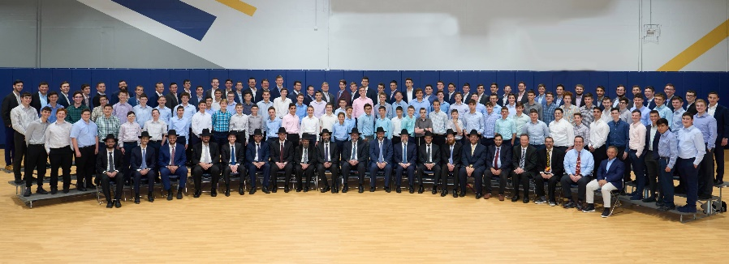
DRESS CODE
Students should dress in a manner that promotes kavod haTorah during school AND non-school hours. Athletic wear and lounge wear may be worn in the dormitory, gym, and other recreational areas, and may not be worn in the other areas of the building. Jeans are not allowed at any time.

Students should maintain proper grooming at all times. Shirts should be kept tucked in and haircuts that reflect Torah standards must be taken regularly. Haircuts are subject to administrative review. Students should be clean-shaven (except during the sefiras h’aomer period.)

On Shabbos and Yom Tov, attire that shows proper respect for the day is to be worn, including when leaving the campus. A hat, suit, tie, white shirt, and Shabbos shoes are to be worn for all tefillos on Shabbos and Yom Tov.

For athletic activities, gym shoes, shorts, and t-shirts (with sleeves) may be worn. Yarmulkes are required at all times.

For Shiurim, Davening, and all Classes:
Our dress code promotes kavod haTorah and fosters a purposeful learning environment. Students should conform to the letter and true spirit of our dress code and will be admitted to classes or tefillos only when they are dressed properly.
Pants - Black, blue, or charcoal gray dress pants; no pants with a jeans-type look (i.e., metal rivets, front-facing pockets, sewn-on pockets); no drawstring waist or elastic bottoms
Shirts - Full button-down dress shirt with traditional collar
Shoes - Dress shoes (leather or rubber soles) with dark, conservative solid-colored upper (no slippers, clogs, or canvas-like shoes).
Low-top black sneakers (100% black, not dark gray, including sole and logo) may be worn as needed for comfort.
Undershirts - White
Socks - must cover the top of the ankle
Yarmulke – all black without designs or names
Sweatshirts – Solid colored, without words or large logos, may be worn as needed for comfort.
Accessories - Medical alert tags may be worn around the wrist or neck. No other necklace, bracelet, or wristband is allowed.

Additionally, For Davening
Hats and Jackets - Suit jackets or conservative sport jackets

Please consult with Rabbi Wachsman for any questions regarding dress code.
SCHOOL ATTENDANCE POLICIES

SCHOOL DAY TIMES
The school day starts with Shacharis at 7:40 a.m., Monday through Friday. On Sundays, Shacharis is at 8:00 a.m.
School is dismissed at 6:30 p.m. or 8:30 pm on mishmar days. (See also Night Seder.) School is dismissed on Sundays at 1:00 p.m. (after Mincha) and on Friday dismissal is at 12:30 p.m.
Parents of local students are responsible for transporting their children to and from Yeshiva.

DRIVING TO YESHIVA
Local students may seek permission from Rabbi Wachsman to drive their cars to and from Yeshiva. In addition, parents of student drivers must sign the permission form in TADS. Any student wishing to carpool to and/or from Yeshiva with another student must have consent from his parents recorded in TADS.
Cars brought to Yeshiva are strictly off-limits during school hours. Students must hand in their keys when they arrive, and keys will be returned when they are leaving for home.

STUDENT PASSENGER POLICY
Parents may opt to allow their sons to ride along in the car of local students or bais medrash students by completing the consent forms in TADS. Checkout permission to drive with student drivers will be granted based upon the permissions allowed in TADS. Please note that permission will be granted during non-school hours only.

MISSING YESHIVA
If a student would like to be excused from class, a parent or the student must contact Rabbi Wachsman before the start of class by email (rabbiwachsman@missouritorah.org,) text, or phone (718-930-7594 - voicemail is fine) detailing the reason for the absence. If Rabbi Wachsman is not informed the absences may remain unexcused and compromise the student’s grade. Particular care must be taken not to miss scheduled tests.

Extended absences, or late arrivals for and early departures from a zman compromise the learning process and success of our students and are therefore strongly discouraged. Any request for such an absence must be made well in advance to Rabbi Wachsman to receive permission. Please do not make assumptions based on past decisions. We will do our utmost to treat each case individually and appropriately while respecting the input of our talmidim and their parents.

Please bear in mind that office staff and teachers are unable to grant permission to miss class.

YESHIVA CALENDAR & TRAVEL
It is crucial that you consult and use the Yeshiva calendar when planning vacations or making travel plans. All students, including dorm students, should arrange to attend school through the last scheduled day prior to vacations, and to return promptly when school is scheduled to resume. All travel must be done on the “travel days” indicated on the school calendar, and all students must return to yeshiva by 9 pm. Please note that some “travel days” may begin in the afternoon.

Travel to and from the airport/bus station/etc. is the responsibility of the student or his parents. The phone number for the Chesterfield Car Service is (314) 209-0448. They will accept pre-payment by a parent’s credit card.

All “checkout” policies are in effect from the time a student arrives in St. Louis until the time he leaves.

SNOW DAYS
On snowy mornings, local students should please be in touch with Rabbi Wachsman (718-930-7594) between 6:45-7:00 a.m. to discuss whether they will be expected to make it to school on time, late, or not at all. A decision regarding afternoon classes will be made by late morning.

CLOSED CAMPUS POLICY
In the interest of student safety, we have a “closed campus” policy. This means that all students must stay on our campus for the entire school day. This includes anything from a trip to the store to a walk with his friends. Permission to go off campus during school hours will be decided on a case-by-case basis and may be granted by Rabbi Wachsman or Rabbi Gewirtz only.

Any student who violates this policy for any reason will be fined $25.00 and will risk loss of checkout privileges.

DAVENING
Davening Shacharis with the Yeshiva is an integral part of the daily schedule, Sunday through Friday. Shacharis begins with berachos at 7:40 a.m. (8:00 a.m. on Sunday) followed by pesukei d`zimra at 7:45 a.m. The Yeshiva davens nusach Ashkenaz. Students will receive a grade for Shacharis based on attendance, timeliness, and appropriate attire. Although a "vecking" (wake up) service is provided in the dormitory, the ultimate responsibility of coming to minyan on time rests upon the student himself. It is suggested that each student have an alarm clock to ensure his ability to arrive punctually to minyan.

NIGHT SEDER AND MISHMAR
Dormitory students will have a night seder Sunday-Thursday evenings from 7:30 to 8:30. Local students will join night seder on Tuesday and Thursday evenings and may join in this program on other nights as well. Regular yeshiva attire is required and regular “during school” standards apply.

STUDENT ID CARDS
MTI students will be issued a student ID card. This card will also serve as an access control card (electronic key,) giving students access to our secure school building. There is no charge for the student ID card, which will be distributed at the start of school. Lost cards should be reported to Mrs. Graff for deactivation and will be replaced at a cost of $10.
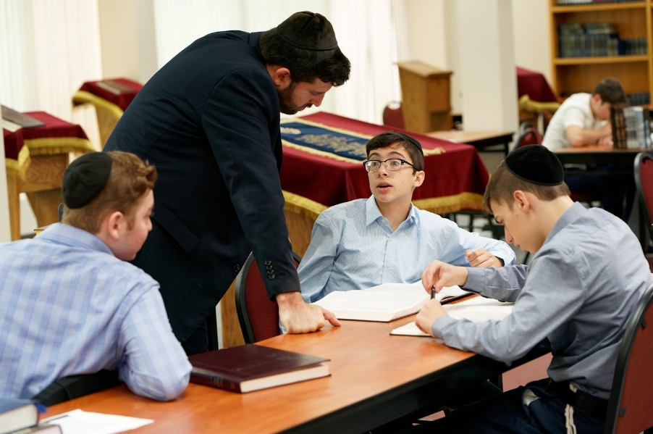

ACADEMIC POLICIES

GRADING POLICIES
A+: | (98-100%) | 4.0 grade points
A: | (93–97%) | 4.0 grade points
A-: | (90–92%) | 3.7 grade points
B+: | (87–89%) | 3.3 grade points
B: | (83%-86%) | 3.0 grade points
B-: | (80–82%) | 2.7 grade points
C+: | (77–79%) | 2.3 grade points
C: | (73-76%) | 2.0 grade points
C-: | (70–72%) | 1.7 grade points
D: | (65–69%) | 1.0 grade points
F: | (under 65%) | 0.0 grade points
- All Judaic and general studies courses that receive a grade will be included in the GPA and on official transcripts.
- Report cards are issued quarterly. The second and fourth quarter report cards will contain both quarter and semester grades.
- A student who earns a GPA above 3.7 in a semester and maintains on-time attendance at tefillos and classes will make the MTI Honor Roll.
- Regular attendance and timely arrival to classes are essential components for a student’s success. Unexcused absences and tardiness will negatively impact a student’s grades. A portion of every course’s grade is based on attendance.
- There are times when a grade of INCOMPLETE must be used to allow a student time to submit missing assignments and/or make up missed exams. In all cases, INCOMPLETE is a temporary grade, and the student will be given a reasonable period of time in which to complete the outstanding work. If the work is not submitted on time, the grade of INCOMPLETE will be changed on the permanent record to an F.

GRADUATION REQUIREMENTS
A student will graduate from Missouri Torah Institute when he completes four years of high school, meets all MTI and state of Missouri graduation requirements. A poor attendance record, including excessive tardiness, may affect a student’s eligibility for graduation.

To graduate from Missouri Torah Institute, all courses and credits required by the state of Missouri as well as by MTI must be completed with a passing grade. Students cannot graduate without successfully completing all their Judaic and general studies courses. Credit recovery involves taking a correspondence course with a fee that is the responsibility of the student and his family. In addition, all financial responsibilities must be in order.

ONLINE GRADEBOOK – JUPITER
Missouri Torah Institute uses Jupiter, an online school management platform, as our gradebook and student information system. Jupiter is an excellent way for students and parents to track their grades, assignments, and attendance. Parents can enroll to receive alerts for grades, attendance, and conduct, and can also use this platform for communicating with teachers and rebbeim. Parents are encouraged to take advantage of this wonderful opportunity to stay informed and involved in their son’s academic progress. Access Jupiter at https://login.jupitered.com/login/?52469.

PERMANENT RECORDS/TRANSCRIPTS
Permanent records will be maintained by MTI and used to generate transcripts. All courses that students take and receive a grade in will be included on the MTI Transcript.

Transcripts may be requested by filling out the form at https://www.missouritorah.org/transcript. Transcripts will be sent out only when all financial obligations are met. This is a uniform policy among private schools and is enforced collaboratively.

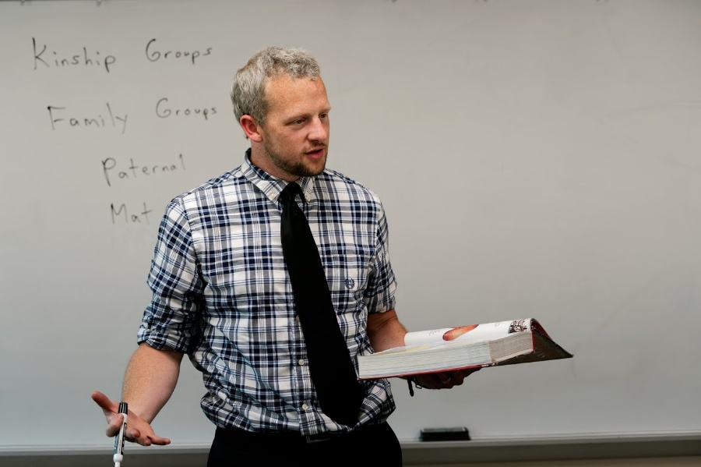

DORMITORY POLICIES

STUDENT CHECKOUT
Our responsibility for the safety and well-being of our students demands that we always be aware of their whereabouts.
Any student wishing to leave the campus or dormitory for absolutely any reason at any time during non-school hours (including Friday, Shabbos, and Sunday) must check out.
Checking out involves giving a detailed itinerary, with each destination made clear, and the expected time of return. This may be done either by phone or in person, as circumstances warrant. This policy includes, but is not limited to, leaving the dorm to spend time at the home of one of our local students or families.
We ask each student to understand the tremendous responsibility the Yeshiva has for their well-being and the corresponding importance of proper compliance with checkout rules.
Any student who violates this policy for any reason will be fined $25.00 and will risk loss of checkout privileges. In certain instances, other consequences may be deemed necessary.
Reflectors must be worn at all times when walking or biking off campus after dark.

CLEANLINESS
Our dormitory is the shared living space of our students and is therefore to be respected. Routine daily tidiness and orderliness (making beds, putting away clothing and laundry, etc.) is the responsibility of each individual student. All items should be stored in closets or drawers, not left on beds, floors, etc. Items left out of their proper places will be removed by the cleaning staff. Students who leave a mess may be asked to clean it, even if it means missing classes or activities.

READING MATERIAL
In addition to the recreational programmming and resouces provided by the yeshiva, reading can be a terrific way for students to spend their free time. All reading material, including books, comic books, and magazines, must be approved prior to being brought into the dormitory.
Please also note policies listed earlier regarding music, electronic devices, and cell phones.

CURFEW
Curfew procedures have been established to ensure that students get the rest they need to maintain success in their learning. Curfew extensions will only be granted in extenuating circumstances. Proper consideration for the needs and feelings of others in the dormitory is necessary under all circumstances.

GUESTS
Only current students of MTI are allowed to stay in the dormitory. Arrangements for any guest, whether for an overnight stay or a Shabbos (in or out), must be made with Rabbi Zachai in advance. Without advance permission, no guest is allowed to stay in the dormitory under any circumstances.

MONEY AND VALUABLES
We urge all students to never leave money or valuables in their dormitory rooms. Giving spending money at frequent intervals or opening a checking/debit account for your son will avoid the need to carry around large sums of money. Personal safes are not allowed in the dorm. Money or valuables can be handed in to Rabbi Zachai to be kept in the Yeshiva’s safe and withdrawn as needed. Missouri Torah Institute bears no responsibility for any theft or loss of property.

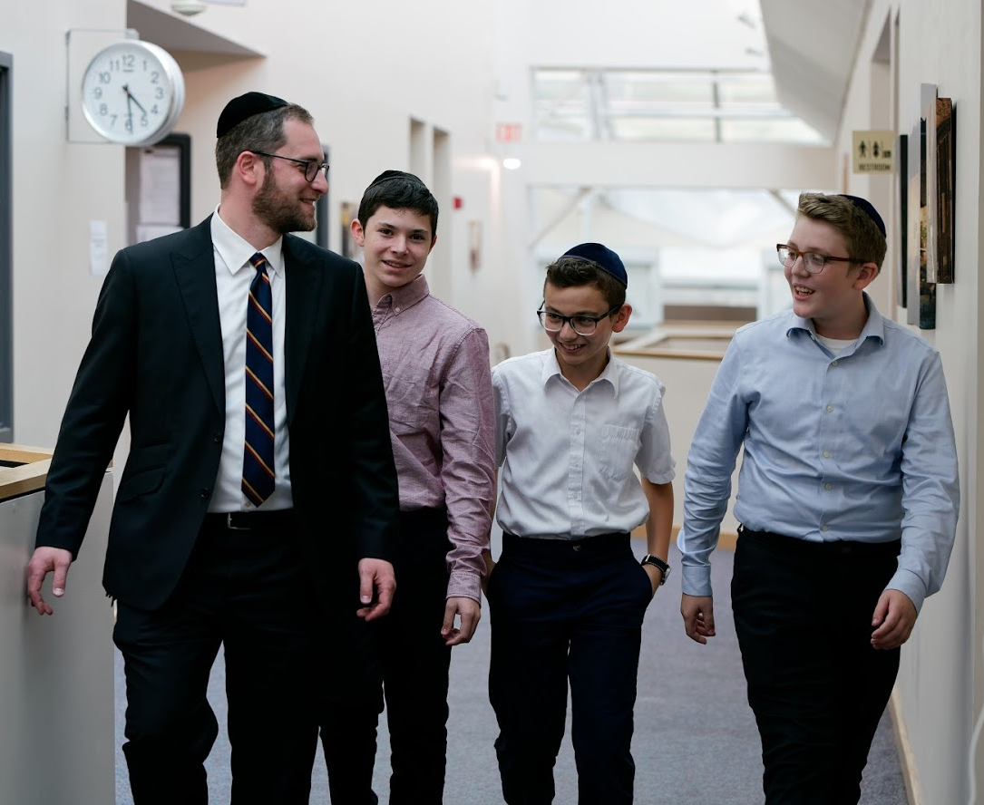

POLICIES RELATING TO SAFETY

AND DAMAGE TO SCHOOL PROPERTY

Many areas throughout the building are available for studying and recreational use while other areas of the building are off-limits. Fines will be assessed for entry into certain off-limits areas where entry may cause considerable damage or loss to the Yeshiva. Signs are posted in these areas.
- The safety of our students is of the utmost importance. Fires are not allowed for any reason. Lighting and/or playing with fire is a cause of danger for the student and his surroundings. Lighting a fire will incur a $250 fine.
- Under no circumstances may the smoke detectors (including infrared beam sensors) be tampered with or disabled. Besides being inherently dangerous, tripping a fire alarm causes an automatic fire department response and the yeshiva incurs a fee. Any student who causes a false alarm will be subject to a $100 fine.
- Fireworks are not allowed on school property.
- Weapons of any kind (BB guns, knives, etc.) are not allowed on school property.
- Dangerous and reckless behavior (i.e., climbing on or jumping from the building structure) is a serious safety concern. To protect the safety of our students, such behavior is grounds for suspension.
- Students are not allowed in the kitchen at any time without explicit permission.
- Any students biking or walking after dark must wear a reflective belt.
- Helmets must be worn always while biking, skate/long-boarding, rollerblading, etc.
- No ball playing, rollerblading, or any other outdoor activity is allowed in the building under any circumstances.
- Bikes must be kept in the designated area.
- Hoverboards may not be used or stored inside or outside the Yeshiva.
- Pictures or signs may not be hung in the dormitory.
- Students may not keep or allow any animals or pets in yeshiva.

We expect students to respect and value the structure and property of the yeshiva and its beautiful campus. Any damage to the building or property will be the financial responsibility of the person liable for the damage. Given the difficulty and expense of repairing damaged items, the Yeshiva reserves the right to decide whether to replace or repair the damaged item. The Yeshiva will determine the amount owed for the damage. The Yeshiva reserves the right to determine which student was responsible for the damage based on circumstantial evidence.

Parents and students will be notified of all damages or fines and the charge will be posted to their TADS account 10 days later. If more time is needed or a different payment method is preferred, it is the parent’s responsibility to communicate and arrange with the business office. Please note, under no circumstance will the Yeshiva ask a student or hold him responsible for payment of these fees.

If repairs are needed or other maintenance problems arise in the dormitory or anywhere in the building, please tell a member of the yeshiva staff. (Details regarding this process will be communicated with students during the school year.) Repairs, alterations, or installations (i.e., nails in walls, stick-on hooks, additional shelves, etc.) may be made only by the school staff. Furniture must never be dismantled or moved, even if it appears to be unneeded or is unused.

STUDENT LIFE

FOOD
Breakfast and lunch are offered for all students. Supper will be available for dormitory students and for local students who will be staying for the night seder or mishmar program.

No food may be taken out of the kitchen without permission from the kitchen staff. Additionally, entering the kitchen is not allowed without prior permission.

Students are allowed to eat and drink in the dining room and student pantry areas only. This ensures the school building will remain clean and allows students to remain focused on schoolwork.

A refrigerator and freezer will be provided for student use. These will be cleaned periodically. Items not claimed after cleaning will become the property of the yeshiva. No personal refrigerators are allowed, in the dormitory or elsewhere.

Food preparation is restricted to the designated area in the student lounge. Some cooking appliances may be available for student use. Additionally, students may bring the following approved appliances to be used in the student pantry:
- Crock pots
- Sandwich, waffle, or panini makers
- George Foreman grills
- Rice cookers
- Coffee maker
Any appliance not listed is not approved.
All approved appliances must be kept in the student pantry, clearly labeled with the student’s name, and cleaned regularly. Any non-approved appliance, any appliance found elsewhere on campus, and appliances not clearly labeled or regularly cleaned, will be confiscated and become property of the Yeshiva.

No fires are allowed for any reason. Under no circumstances may smoke detectors be tampered with or disabled.

LAUNDRY & DRY-CLEANING
The dormitory laundry facility has coin-operated washing machines and dryers, owned and managed by a private company. A dry-cleaning service picks up and drops off clothing at the yeshiva twice each week.

LOCKERS
Lockers will be available for each student. Classrooms are cleaned daily; therefore, books and personal items should be stored in lockers only.

MAIL AND PACKAGES
Students may have mail and packages delivered to Yeshiva. Mail and packages will be delivered to the office and will be placed in the coat room daily at a specific time. To ensure the safety of the yeshiva dormitory, mail and packages are subject to inspection.

LOST AND FOUND
The Yeshiva will maintain a lost and found area. Students will periodically be asked to claim those items which are theirs. Those items not claimed will be disposed of. Additionally, the cleaning staff will be cleaning the entire building, including classrooms, dormitory, and other areas, on a regular basis. Any items not in their proper place will be removed.

ILLNESS
If a student becomes ill, the Yeshiva will provide for and arrange all services, as necessary. Local students who become ill at school should come to the office. We will contact parents at that time.

Dealing with medical issues from a distance is one of the great challenges of a parent with a son who is away from home. We make every effort to ensure that our students receive proper medical care, and we take particular care to look after any student who is sick. At the same time, we view your involvement as critical in helping to deal with any medical situation that may arise regarding your son. Should you have any medical concern regarding your son, please contact the Yeshiva. Please see the Procedures for Medical Issues policy in the enrollment section of TADS.

SPECIAL EVENTS AND FIELD TRIPS
Most regular dormitory activities are covered by the trip fee. Missouri Torah Institute will also conduct special events, including guest speakers, special classes, field trips and shabbatons, to enhance the ruach amongst the students and rebbeim. Parents may be asked to defray the costs of some of these events. Parents will be notified in advance and given the option to pay by cash, check or use their TADS account. Fees not paid by the date of the event will automatically be deducted from their TADS account within 10 days of the event. Parental permission will be solicited when appropriate.

OUT SHABBOS
The Out Shabbos is designed for the students to have a break from the Yeshiva schedule and provide an opportunity to rejuvenate. The dormitory will remain open and supervised for the boys who wish to remain. Talmidim may leave the Yeshiva for Shabbos if the guidelines set up by the Yeshiva are met.

Parents are welcome to arrange to bring their son home for an Out Shabbos. Parents must inform Rabbi Wachsman of these arrangements.

Please be aware that no student will be allowed to spend time in the home of a family where there are high school-aged girls.

The out Shabbos begins on Thursday at 1:00pm and ends Sunday night at 9:00pm. If you have any questions about out Shabbos scheduling, please contact Rabbi Wachsman.

There are five times during the year that the dormitory is closed: Sukkos break, Shabbos Chanukah, winter break, Purim, and Pesach break. All students must go home during these times.

Please note: The contents of this handbook may be revised as deemed necessary.

